
SOP Title: | eCommerce Order Fulfillment Process by Geodis
Document Storage Location: | STACS/Management/SOPs – Logistics and Warehousing | Document #: | SEASOP383v100
SOP Originator: | Paritosh Mehta | Last Edited by: | Paritosh Mehta
Effective Date: | 07/20/2020 | Last Edited Date: | 10/07/2020
Other:

- Purpose
  - To fulfill orders by enabling the process of picking, packaging and shipping within the ecommerce operations.
- Scope
  - Coppell eComm Program – Process to occur when orders are entered in 3PL’s system.
- Responsibilities
  - 3PL Management shall be responsible for ensuring that orders dropped before 3 pm be shipped out on the same day.
  - SEA eComm team shall be responsible for providing support and resolution for system processing errors reported by 3PL Management.
- Instructions:
  - Context Prior to Order Fulfillment Process:
    - An Order made on the Samsung website drops into 3PL system. The status in Visibility software shows as “Entered”.
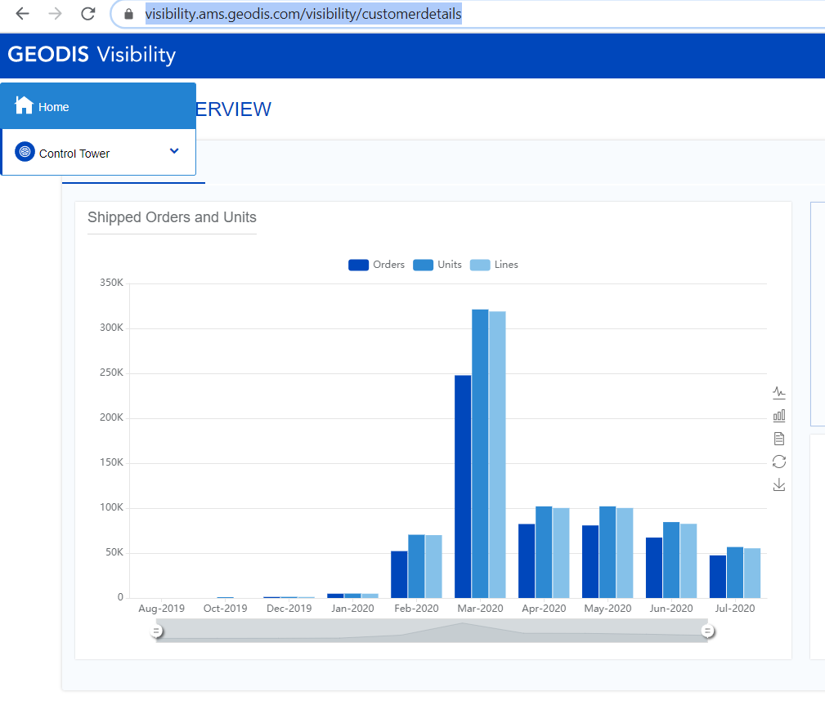
Go to https://visibility.ams.geodis.com/visibility/customer > Sign in > Click on ‘Control Tower’

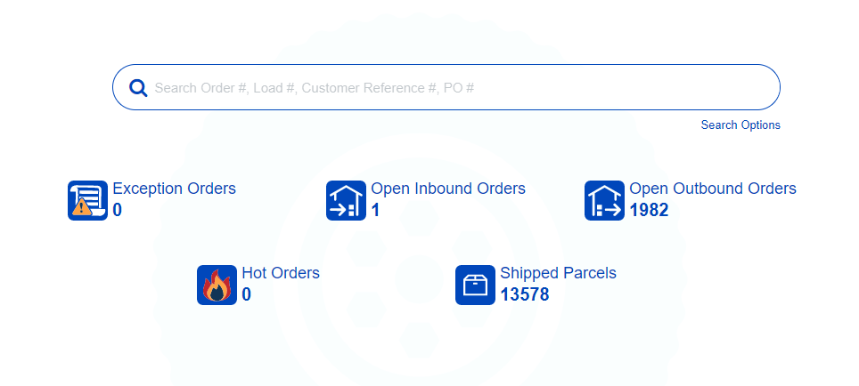
Enter Purchase Order ID

Order Status: Entered
    - The Order is systemically accepted meaning that inventory is allocated to the order. The status in Visibility software shows as “Committed”.
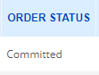
  - Shipping labels are printed manually by 3PL for a batch of “Committed” orders in the 3PL Control Center. Once printing is complete the status in Visibility changes to “Released”.
  - 3PL resource takes the labels and places each label in an empty box pre-staged on a picking cart. The picking carts are staged next to the 3PL eComm Control Center.
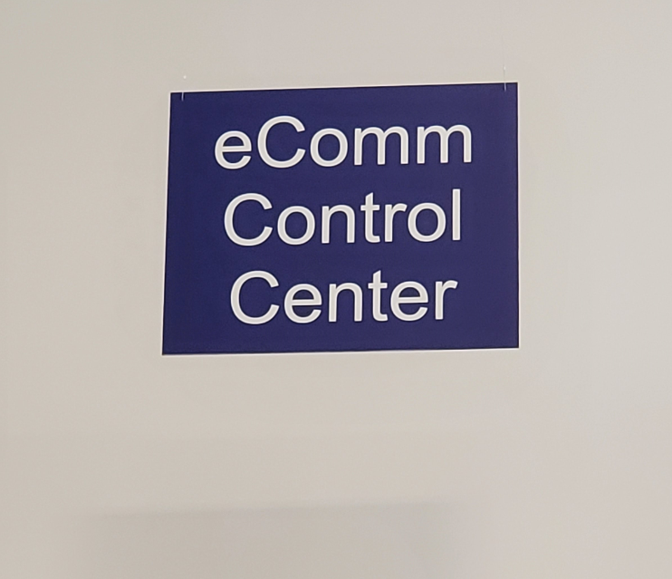
Fig: Signage over Control Center

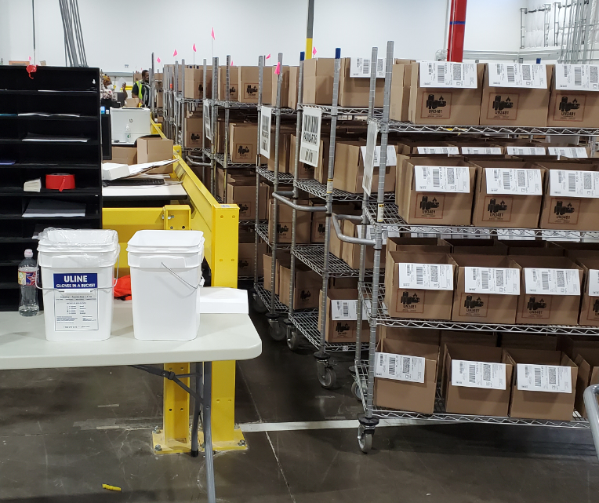
Fig: Picking carts staging area, next to control center
  - Picking (Normal orders):
    - A picker selects a particular cart
    - The picker scans all the labels on the cart
    - The 3PL system identifies the particular material and bin location to pick
      - Note: Locations are available in shelves of the designated picking aisles, as well as pallets on the designated floor space for fast moving items.
    - The cart is moved to the first location where the picker places their bin marker to the said location to minimize errors due to misplacement of the items by having the visible indicator during the picking process.
    - The picker then scans the location, the item and the pick ticket to verify the pick.
    - If they all match, the item(s) is placed inside the box with the pick ticket.
    - The status in Visibility changes to “Picking Complete” for each order as it is completed.
  - Picking (Carrier Finance orders):
    - A Geodis staff assigns a set of Carrier Finance orders to a picker in the system, informing the picker about the assignment, and provide un-scanned location ID tickets
    - The 3PL system identifies the particular material and bin location to pick
    - The picker receives all the required information updated in their handheld scanning device
    - The picker picks the items from the location, while using bin markers to mark said locations
    - The picker then scans the location, the item and the location ID ticket to verify the pick.
    - If they all match, the item(s) is placed inside the box with the location ID ticket, and the boxes are placed on a separate designated pick front.
      - The material (box) stays in this location until either the Carrier approves the order or the DO is cancelled.
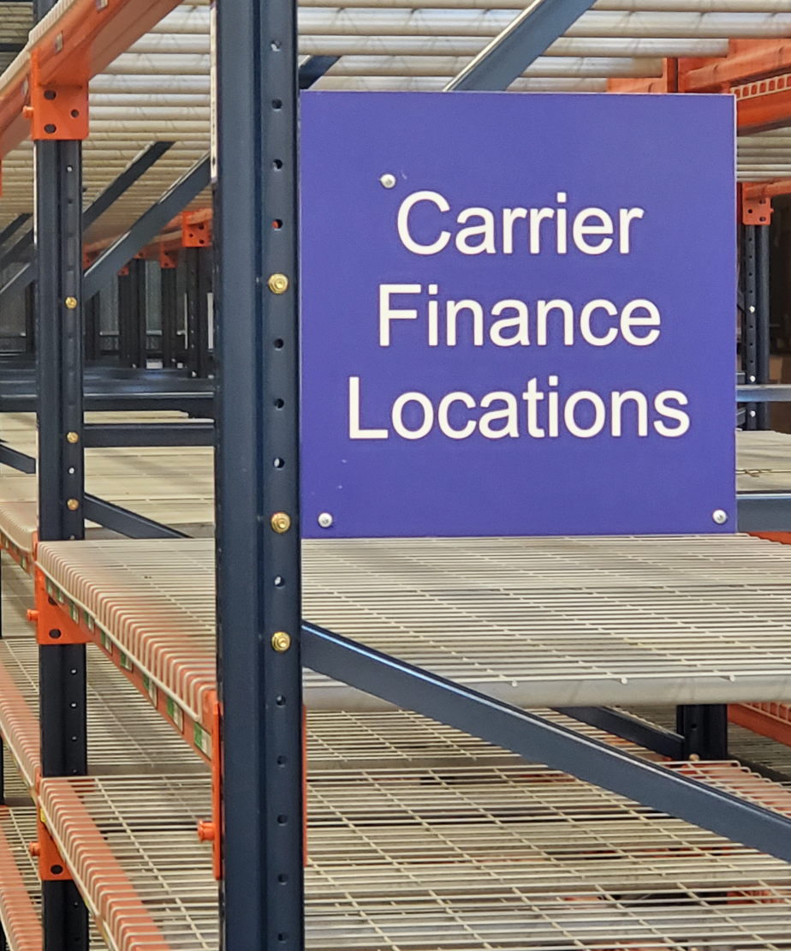
Fig: Designated Carrier Finance Pick Front
    - The status in Visibility changes to “Picking Complete” for each order as it is completed.
    - Systemically, the IMEI information then gets transmitted to the network carrier associated with the order
    - Once the IMEI information and related EDI is received by the network carrier, the network sends the approval message back to Geodis system within 24 hours
    - In the event that the message is ‘not approved – Carrier rejected’, or the order takes more than 24 hours to be approved, the order gets canceled, prompting Geodis to de-pick the order
      - Geodis unpicks the material in the Synapse (proprietary process)
      - Physically return material to a regular bin with the same SKU.
    - The Geodis staff prints all the orders that gets approval message in the system , and submits the paper to the designated picker, where the picker picks the orders from the staged area , and continues according to the normal order picking process
  - Once the picking is complete for all orders on the cart the cart is staged in the Back-End-Label (BEL) Picked Cart Staging area. Carrier Finance orders are labeled separately from non CF orders at designated BEL label stations.
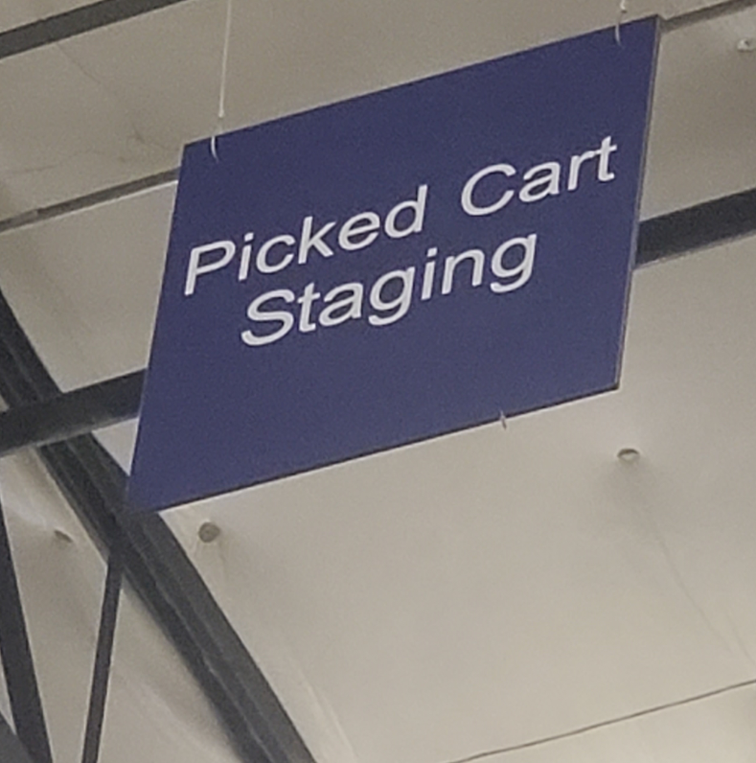
Fig: Signage over Picked Cart Staging Area
  - An auditor validates the orders on the cart by scanning the picking list and the material in each box, verifying that the right SKUs and quantities have been picked according to the labels.
    - If quantity, material or serial is incorrect then the system will fail the audit.
    - The 3PL resource brings the failed order box and contents to Lead or Supervisor for resolution.
    - The person does their research for the reason of audit failure, against a list of common failures.
    - Once the reason is determined, it is rectified and the audit is cleared.
    - The order is staged before the packing area to pack and ship.
  - The Front-End-Labeled orders are placed on the packing conveyor and packed in the Packing Area at Packing Stations.
    - Each packing station is provided with sample boxes based on the SEA specifications.
    - 3PL follows packaging procedure per SEA/3PL specifications.
  - After the orders are packed, the packages are “ship-scanned” to validate the type of shipment and status. The status in Visibility changes to “Shipped”.
Order Status: Shipped, Closed Date included (shipped date)
  - According to the codes on the labels, a package is placed on one of three pallets: Standard Overnight, Two-day Shipping or Home Delivery (Ground).
  - Once a pallet is complete, it is wrapped and staged in the eComm ship staging area for delivery to FedEx. Overnight and 2nd day pallets are loaded (by FedEx) in door N22. Home Delivery pallets are loaded by Geodis into a pre staged trailer in door N15.
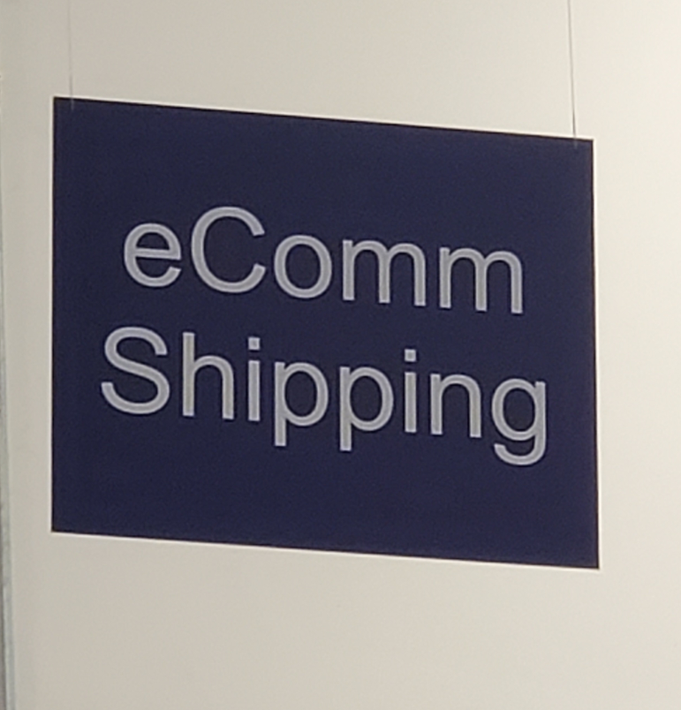
Fig: Signage over eComm shipping area

    - Two FedEx trailers are staged at the docks until filled.
      - 2-Day shipping material goes on one trailer.
      - Ground shipping material on the other trailer.
    - FedEx picks up the Overnight shipping material each day separately.

